1. What are the various elements of the Excel interface? Describe how they're used.

Answer:

* Title Bar – Displays the name of the workbook and Excel. It also includes minimize, maximize, and close buttons.
* Quick Access Toolbar – Located at the top-left, it provides quick access to commonly used commands like Save, Undo, and Redo. It can be customized.
* Ribbon – A set of toolbars organized in tabs (Home, Insert, Page Layout, etc.) that contain groups of related commands for formatting, data, formulas, and more.
* Tabs and Groups – Each tab has groups such as Font, Alignment, Number under the Home tab. Groups organize related commands together.
* Name Box – Shows the cell address of the currently selected (active) cell (e.g., A1). It can also be used to name a cell or range.
* Formula Bar – Displays the contents of the active cell. It is used to enter or edit formulas and data.
* Worksheet Area – The main grid of cells made up of rows and columns where users input data.
* Rows and Columns – Columns are labeled A to Z (and beyond), and rows are numbered 1 onwards. A cell is the intersection of a row and column.
* Sheet Tabs – Located at the bottom, used to switch between different worksheets in the same Excel file. Users can also rename, delete, or add new sheets.
* Status Bar – Found at the bottom of the window. It shows information like sum, average, or count of selected cells and lets you change worksheet views.
* Scroll Bars – Vertical and horizontal bars that help navigate the worksheet when it is too large to fit on the screen.
* Zoom Control – Located in the bottom-right corner, it allows the user to zoom in or out of the worksheet view.

1. Write down the various applications of Excel in the industry.

Answer:

Excel is widely used in different industries for various purposes. Some of the main applications are:

* Accounting and Finance – Used for budgeting, financial analysis, profit/loss statements, balance sheets, and tax calculations.
* Data Entry and Management – Helps in storing, organizing, and managing large amounts of data in a structured way.
* Data Analysis and Reporting – Used to analyze data with formulas, charts, pivot tables, and conditional formatting for better decision-making.
* Human Resource Management – Maintains employee records, attendance, payroll, and recruitment tracking.
* Sales and Marketing – Tracks sales performance, customer data, marketing campaigns, and product pricing analysis.
* Inventory and Supply Chain – Manages stock levels, purchase orders, supplier lists, and product tracking.
* Project Management – Used for planning, scheduling, tracking tasks, and managing timelines and budgets.
* Administration – Helps in preparing reports, lists, databases, and official documents.

1. On the ribbon, make a new tab. Add some different groups, insert commands in the groups and name them according to their commands added. Copy and paste the screenshot of the steps you followed.

Answer

Step 1: Open Excel.

Step 2: Go to File > Options > Customize Ribbon.

Step 3: Click on "New Tab" on the right side.

Step 4: Rename the new tab (e.g., My Tab) by clicking on the Rename button.

Step 5: Click on "New Group" under your new tab > Rename the group (e.g., Formatting Tools).

Step 6: On the left panel, choose commands like:

Bold, Font Color, Merge & Center

Click Add >> to move them into your custom group.

Step 7: Create another group (e.g., Insert Tools) → Add commands like:

Insert Picture

Insert Shapes

Step 8: Click OK to apply. You will now see the new tab on the Ribbon.

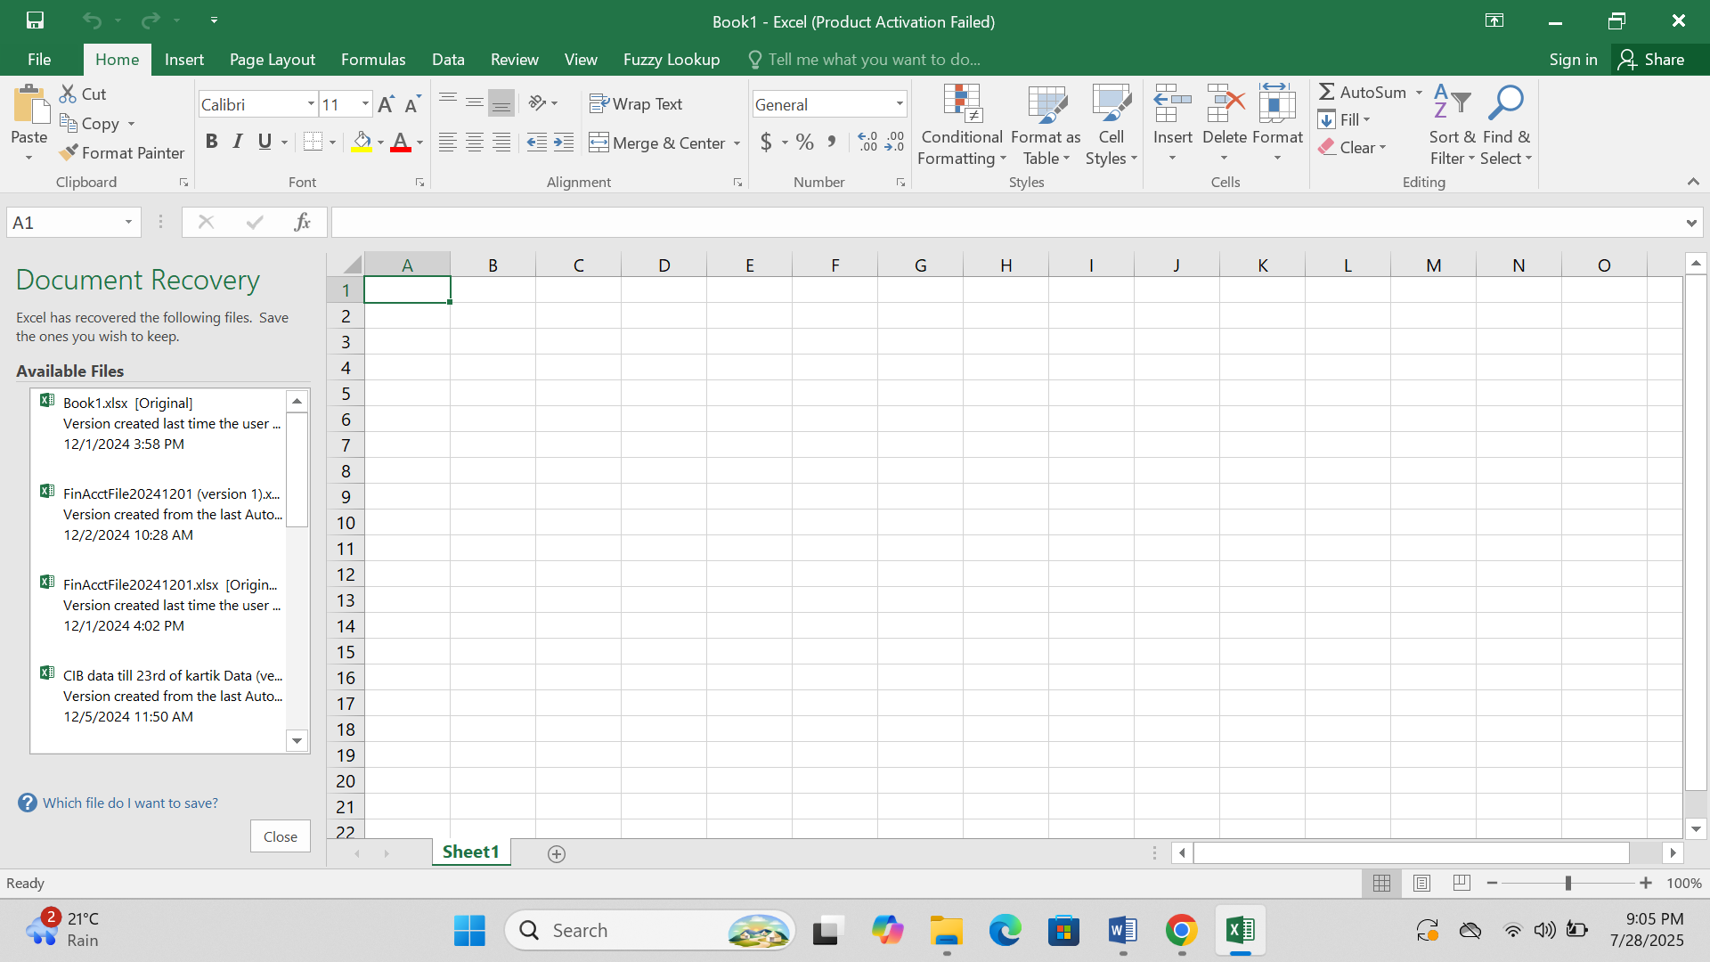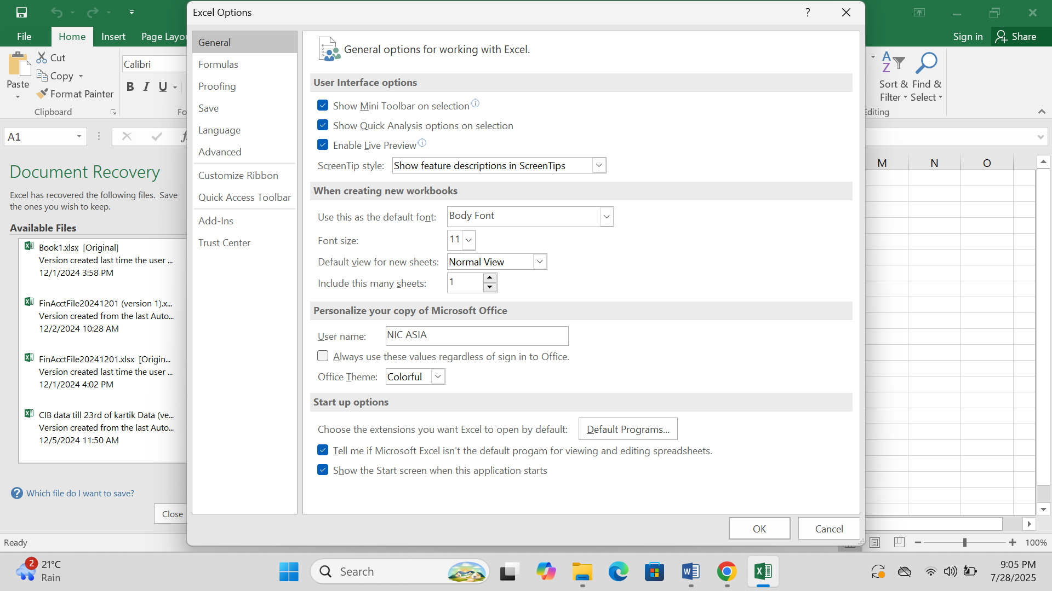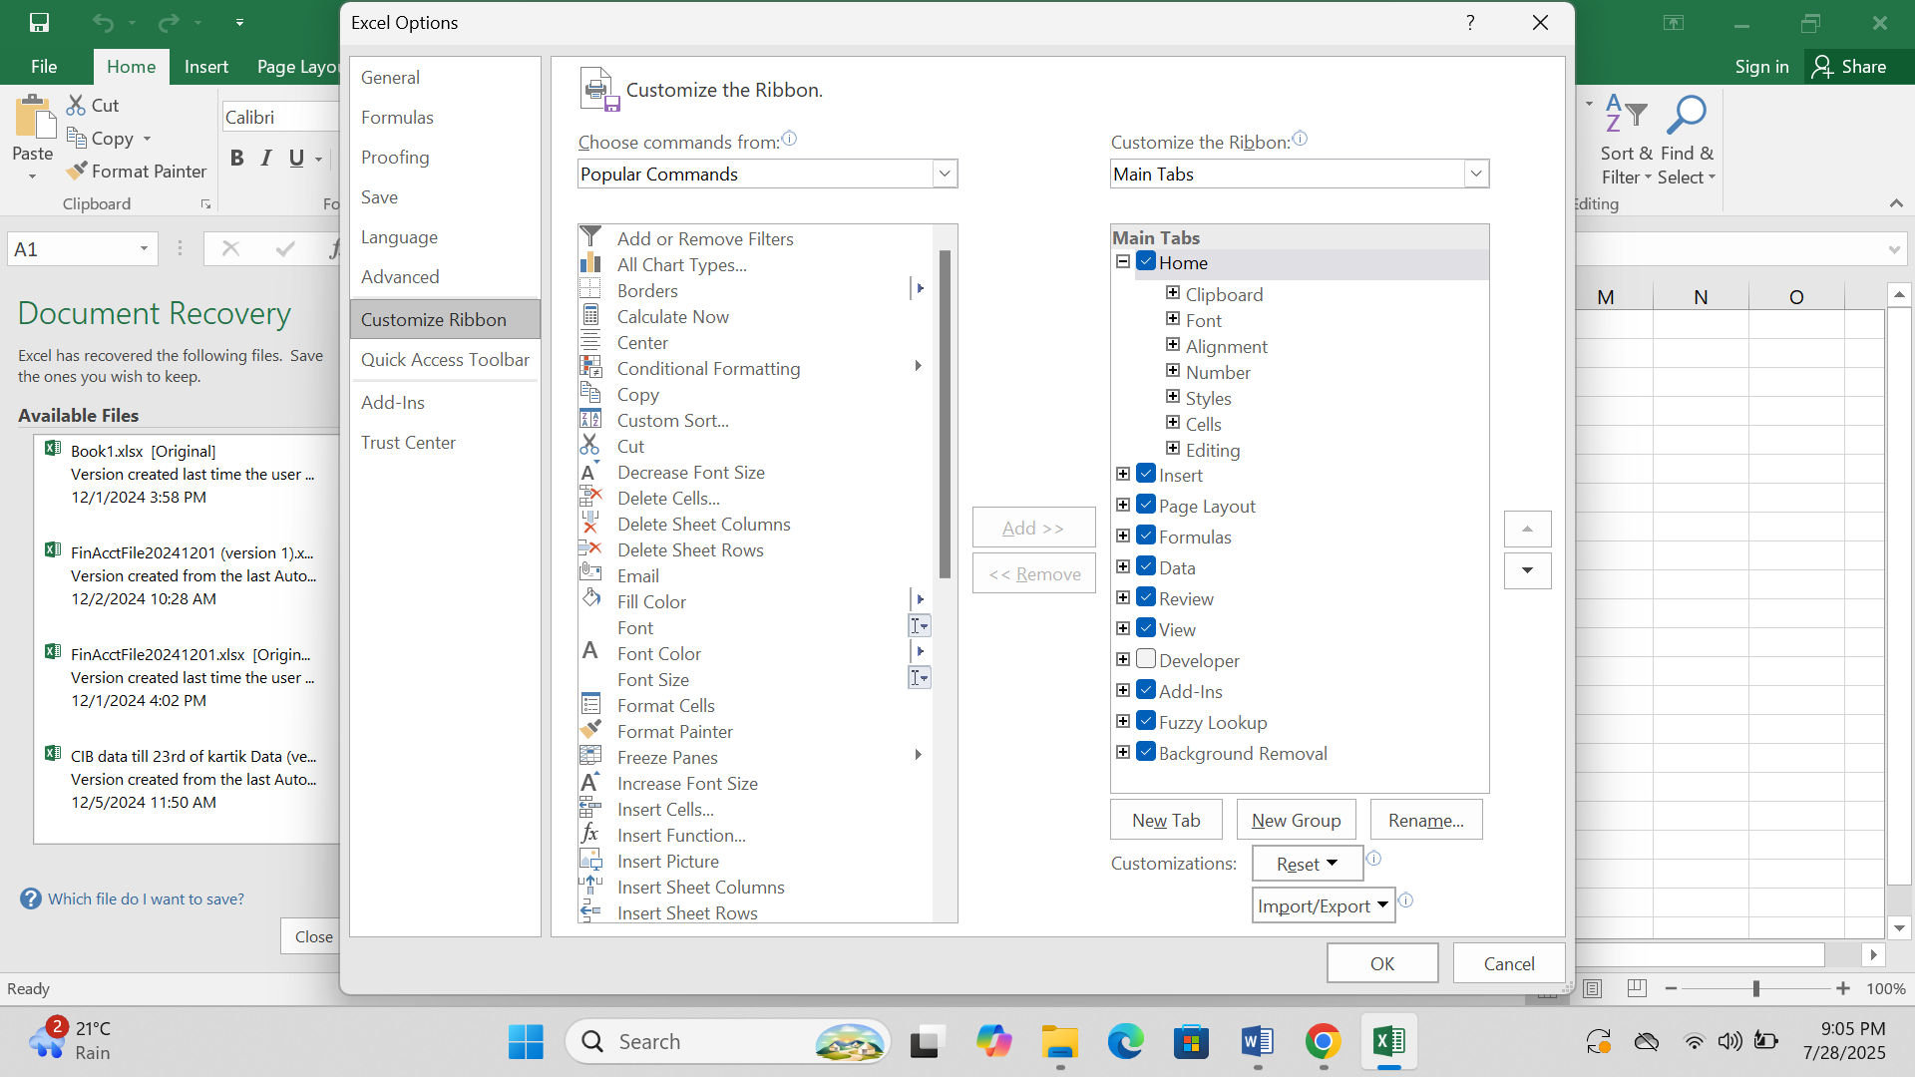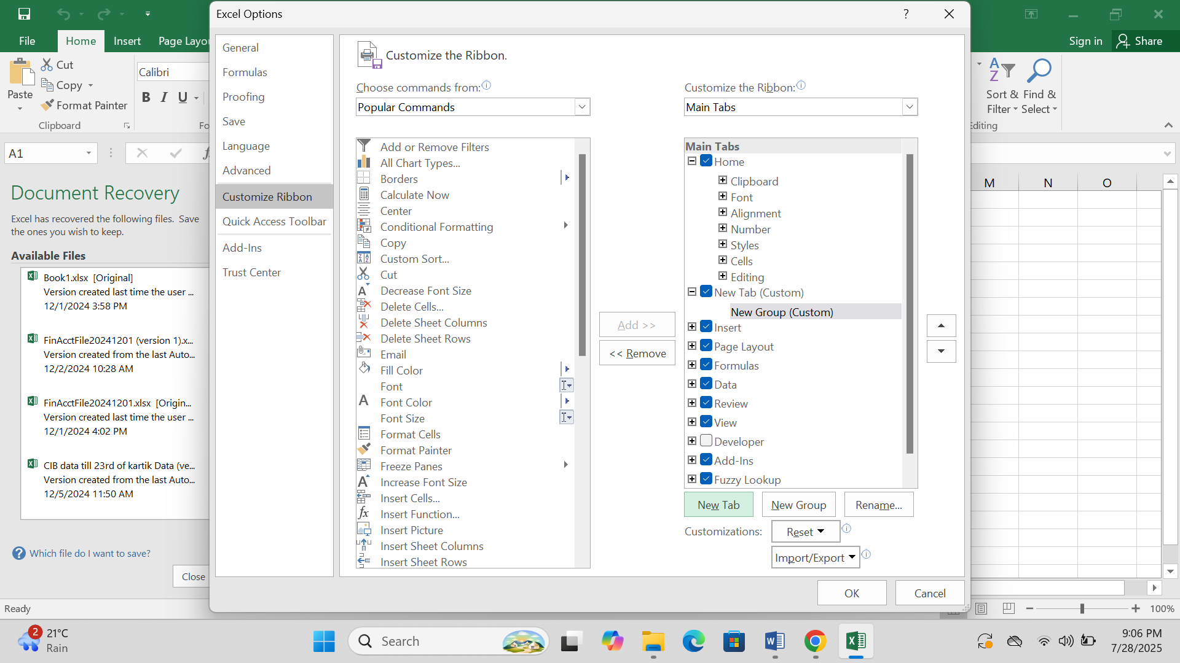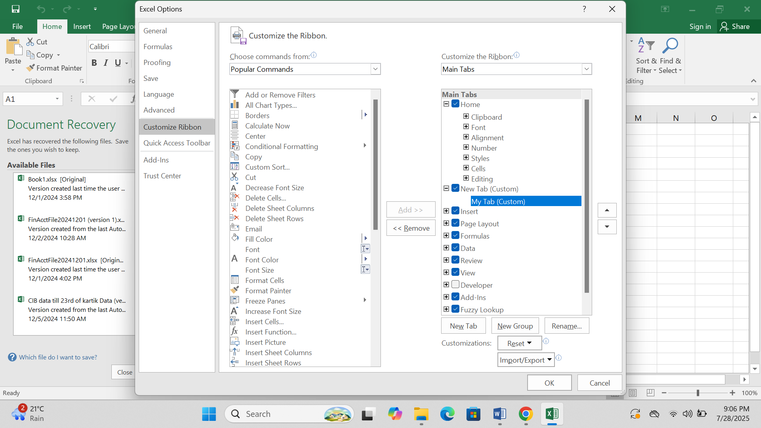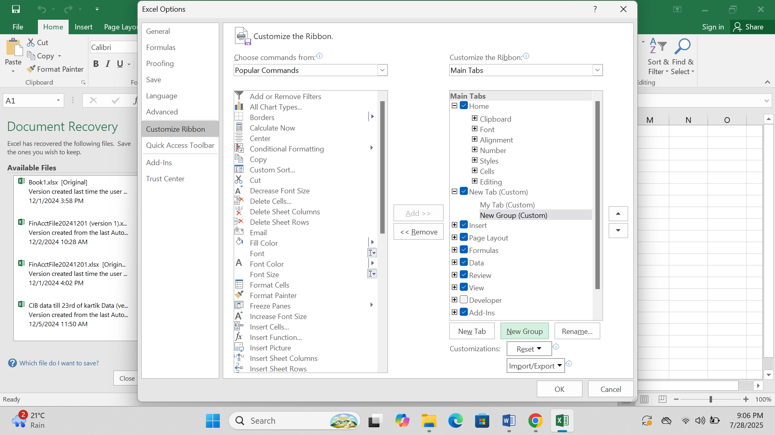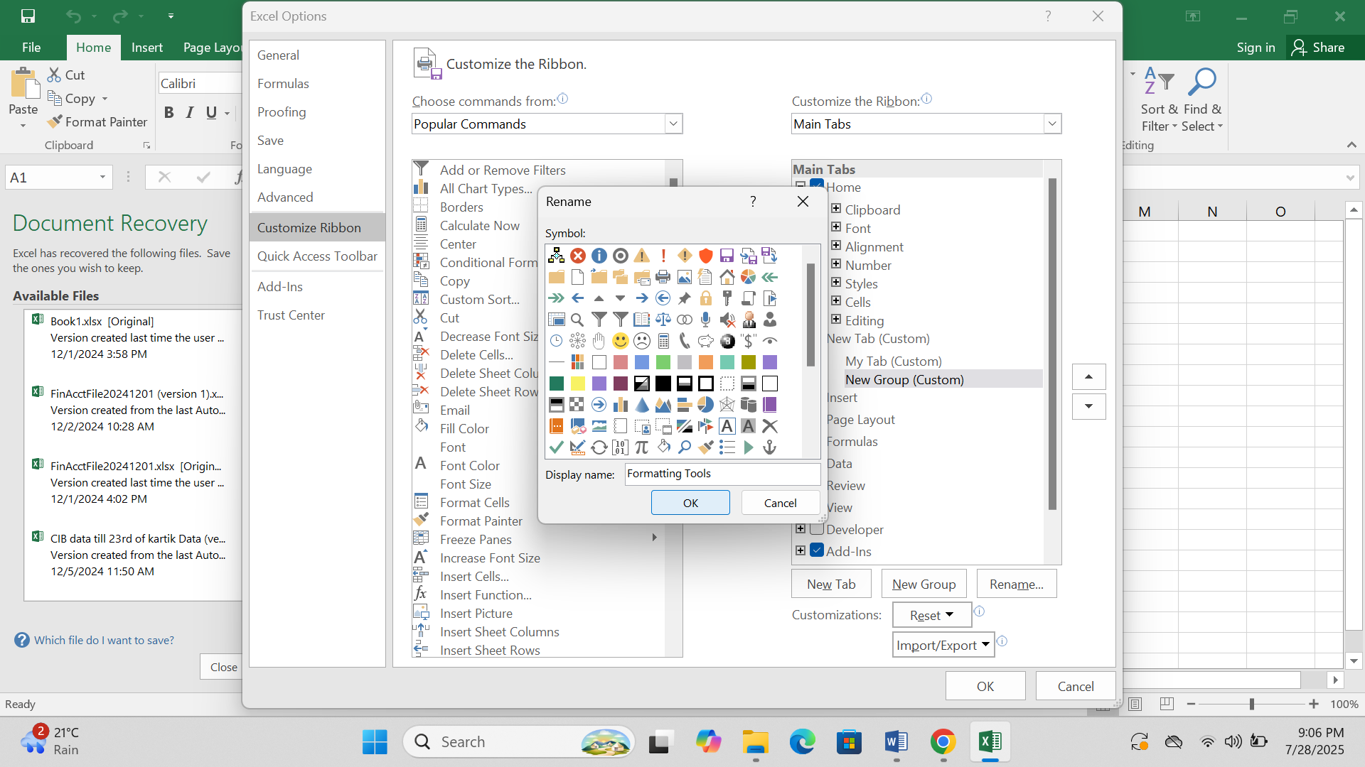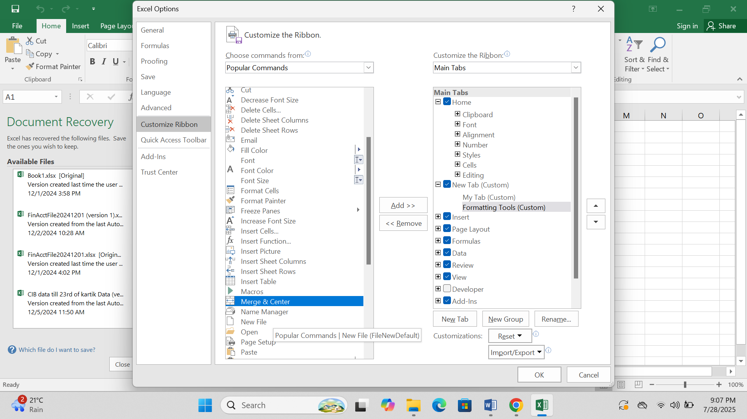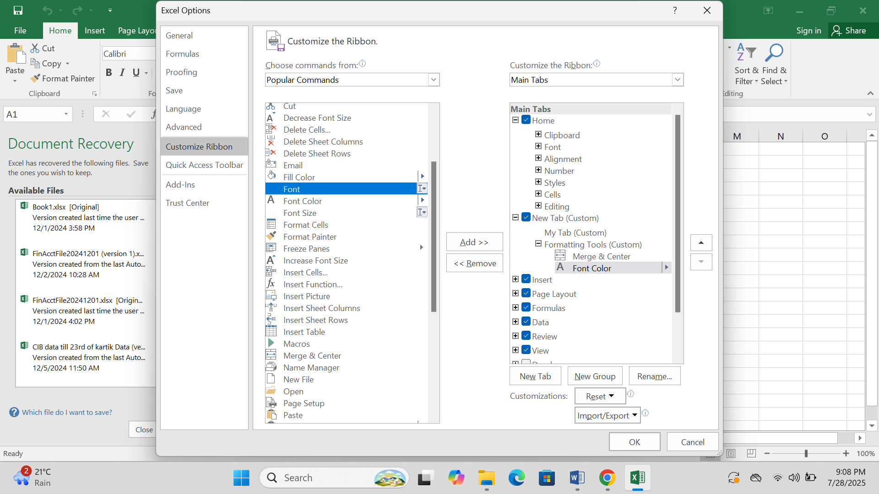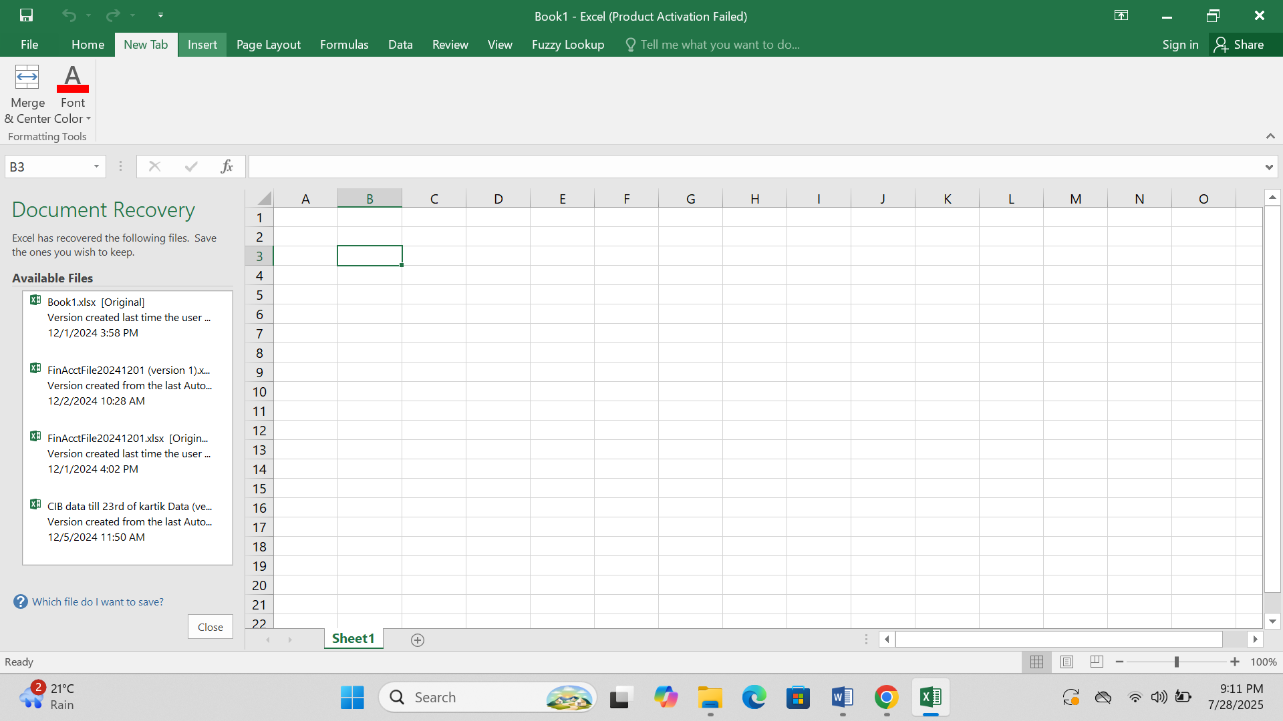

1. Make a list of different shortcut keys that are only connected to formatting with their functions.

|  |  |
| --- | --- |
| **Shortcut Key** | **Function** |
| **Ctrl + B** | Makes the selected text **bold** |
| **Ctrl + I** | Makes the selected text *italic* |
| **Ctrl + U** | Underlines the selected text |
| **Ctrl + 1** | Opens the Format Cells dialog box |
| **Ctrl + Shift + $** | Applies currency format |
| **Ctrl + Shift + %** | Applies percentage format |
| **Ctrl + Shift + #** | Applies date format |
| **Ctrl + Shift + @** | Applies time format |
| **Ctrl + Shift + ^** | Applies scientific number format |
| **Ctrl + Shift + !** | Applies number format with 2 decimals |
| **Ctrl + Shift + &** | Adds border to selected cells |
| **Ctrl + Shift + _** | Removes outline border |
| **Alt + H, H** | Opens Fill Color menu |
| **Alt + H, F, C** | Opens Font Color menu |
| **Alt + H, M, C** | Merges and centers selected cells |
| **Alt + H, A, C** | Centers text in the cell |
| **Alt + H, W** | Wraps text in the cell |

1. What distinguishes Excel from other analytical tools?

Answer:

Microsoft Excel is different from other analytical tools because of the following reasons:

* Simple interface and easy to learn for beginners.
* Pre-installed or widely available in most workplaces and schools.
* Used for both basic tasks (data entry) and advanced tasks (analysis, dashboards).
* Offers a wide range of built-in formulas and functions for quick calculations.
* Allows users to create charts, graphs, and conditional formatting easily.
* Supports macros and VBA to automate repetitive tasks.
* Works well with Word, PowerPoint, Outlook, and other Microsoft tools.
* Ideal for small to medium-sized data for fast, ad-hoc analysis.
* Doesn’t need powerful hardware or setup like advanced BI tools (e.g. Power BI, R, Python).

1. Create a table and add a custom header and footer to your table.

